**📊 Key Visualizations**

**1. Top 10 Best-Selling Products**

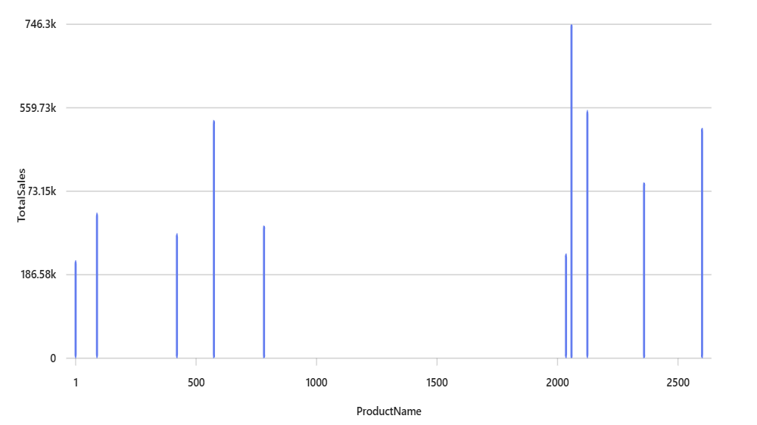

**2. Sales Distribution by Product Category**

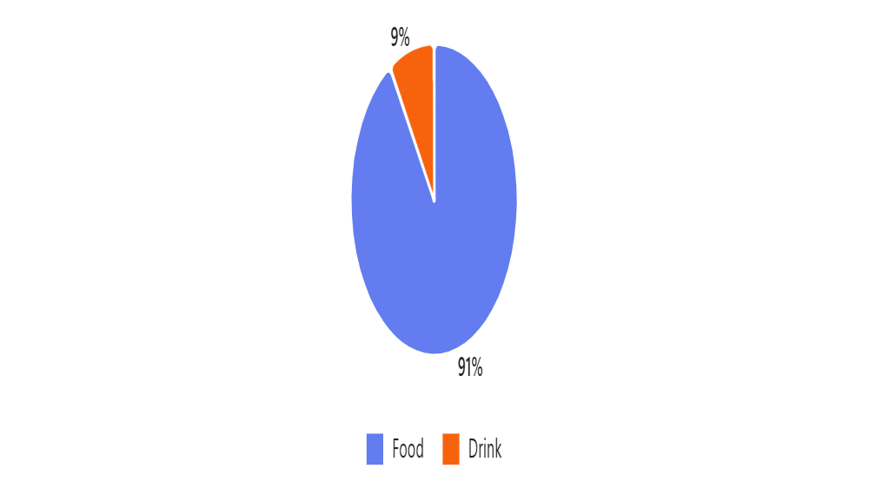

**3. Monthly Sales Trend**

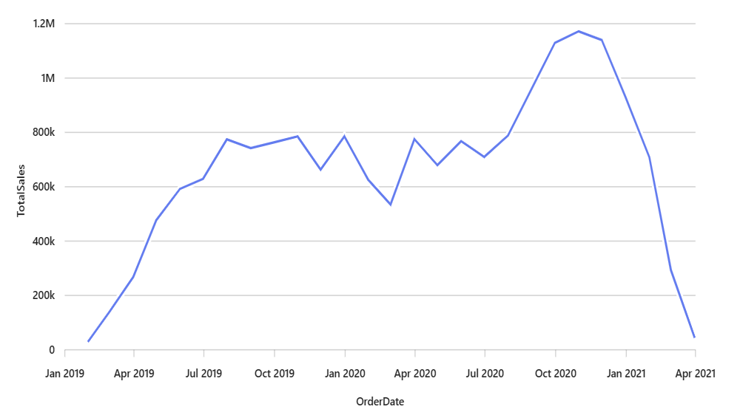

**4. Sales by Channel**

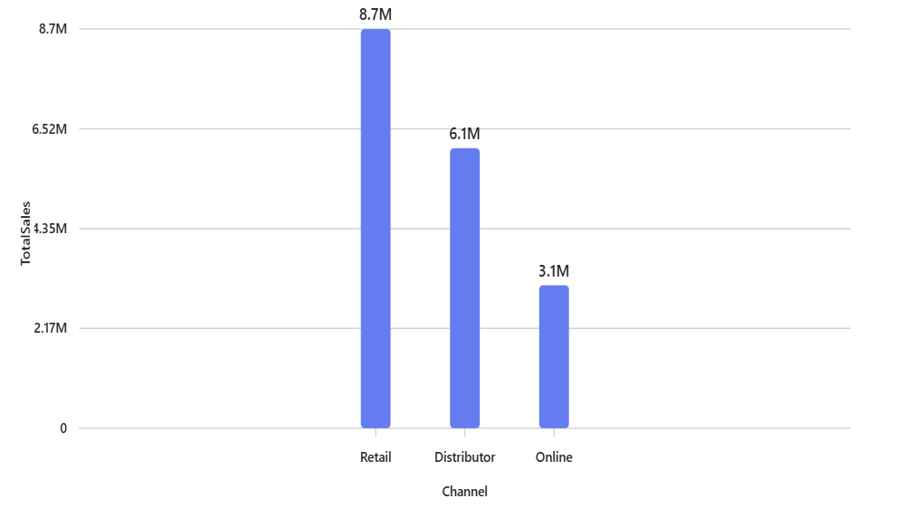

**5. Top 10 Salespersons**

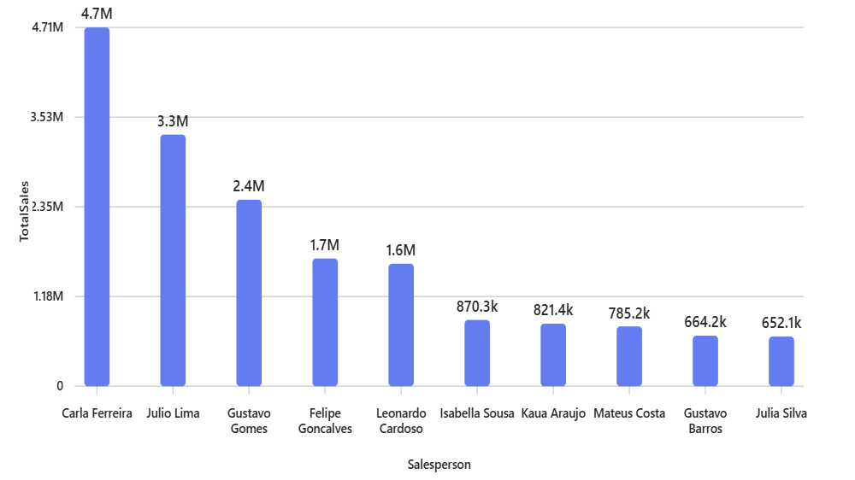

**📌 Summary Insights**

* **Top Product:** **Product 1968** — This product generated the highest revenue.
* **Top Category:** **Food** — Dominates overall sales.
* **Best Channel:** **Retail** — Outperforms Online and Distributor channels.
* **Top Salesperson:** **Carla Ferreira** — Leading in total sales.

**🚀 Recommendations to Increase Sales**

1. **Focus on High-Performing Products**
   * Promote **Product 1968** and other top sellers through targeted campaigns.
   * Bundle them with lower-performing products to boost overall sales.
2. **Strengthen Retail Channel**
   * Since **Retail** is the most profitable, invest in retail partnerships, in-store promotions, and better shelf placement.
3. **Empower Top Salespersons**
   * Recognize and incentivize top performers like **Carla Ferreira**.
   * Use their strategies as training material for others.
4. **Optimize Product Mix**
   * Analyze low-performing products and consider discontinuation or repositioning.
   * Focus on categories like **Food**, which have consistent demand.
5. **Seasonal Promotions**
   * Use the **Monthly Sales Trend** to identify peak seasons and plan promotions accordingly.
6. **Channel Diversification**
   * Improve **Online** and **Distributor** channels with better digital marketing, user experience, and logistics.